A complete range of Ball Transfer Units
from HPC
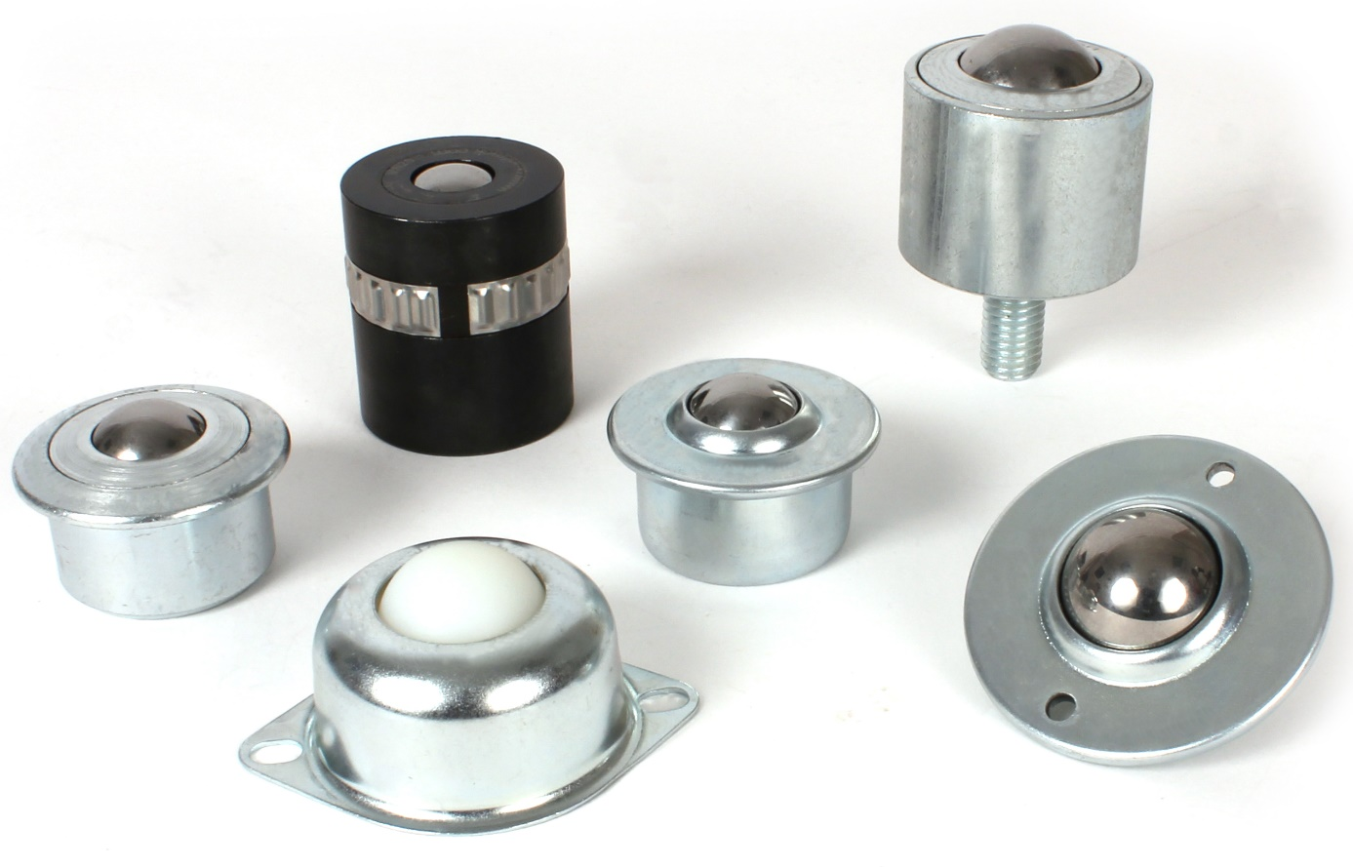

In order to be able to satisfy the demands of their customers, Engrenages HPC is expanding its range of load-bearing ball transfer units. These are multidirectional handling systems used in all sectors of industry to move heavy and bulky loads but with minimum effort. Main applications are packaging lines, sheet metal working, bending or stamping machines and conveyors, but many other applications are also possible.

Ball transfer units consist of a metal or plastic body, in which a main ball is placed, supported by other smaller balls that serve to eliminate friction.

Pressed sheet metal models are preferred for light-load applications. They allow the movement of a load with a good fluidity of movement at a low total cost.
Machined steel housing versions are typically used for heavier loads or where there is the risk of collision between parts being moved.

Engrenages HPC offers a complete range of models in steel, stainless steel or plastic. These include flanged versions, flush-mounted models, higher profile versions and models that are mounted using a thread or spring. A matching mounting clip is also available.

